HTML DOM

First screenshot explains what is HTML DOM.

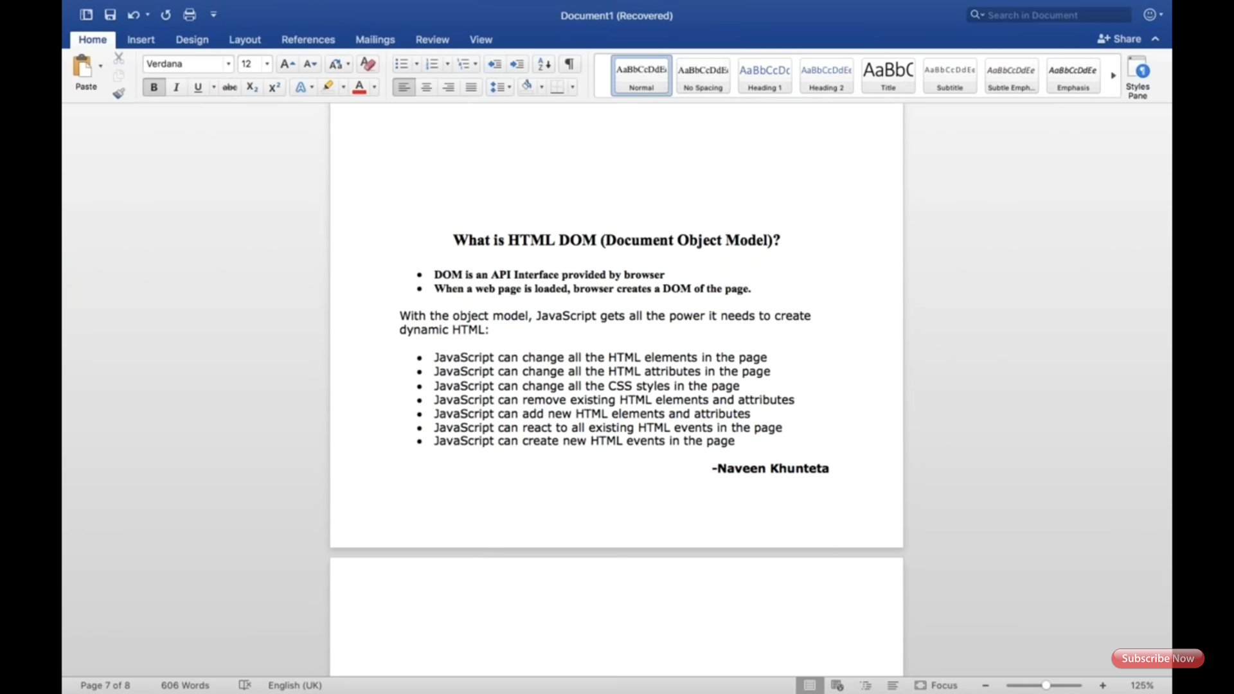

Second screenshot explains structure of DOM.

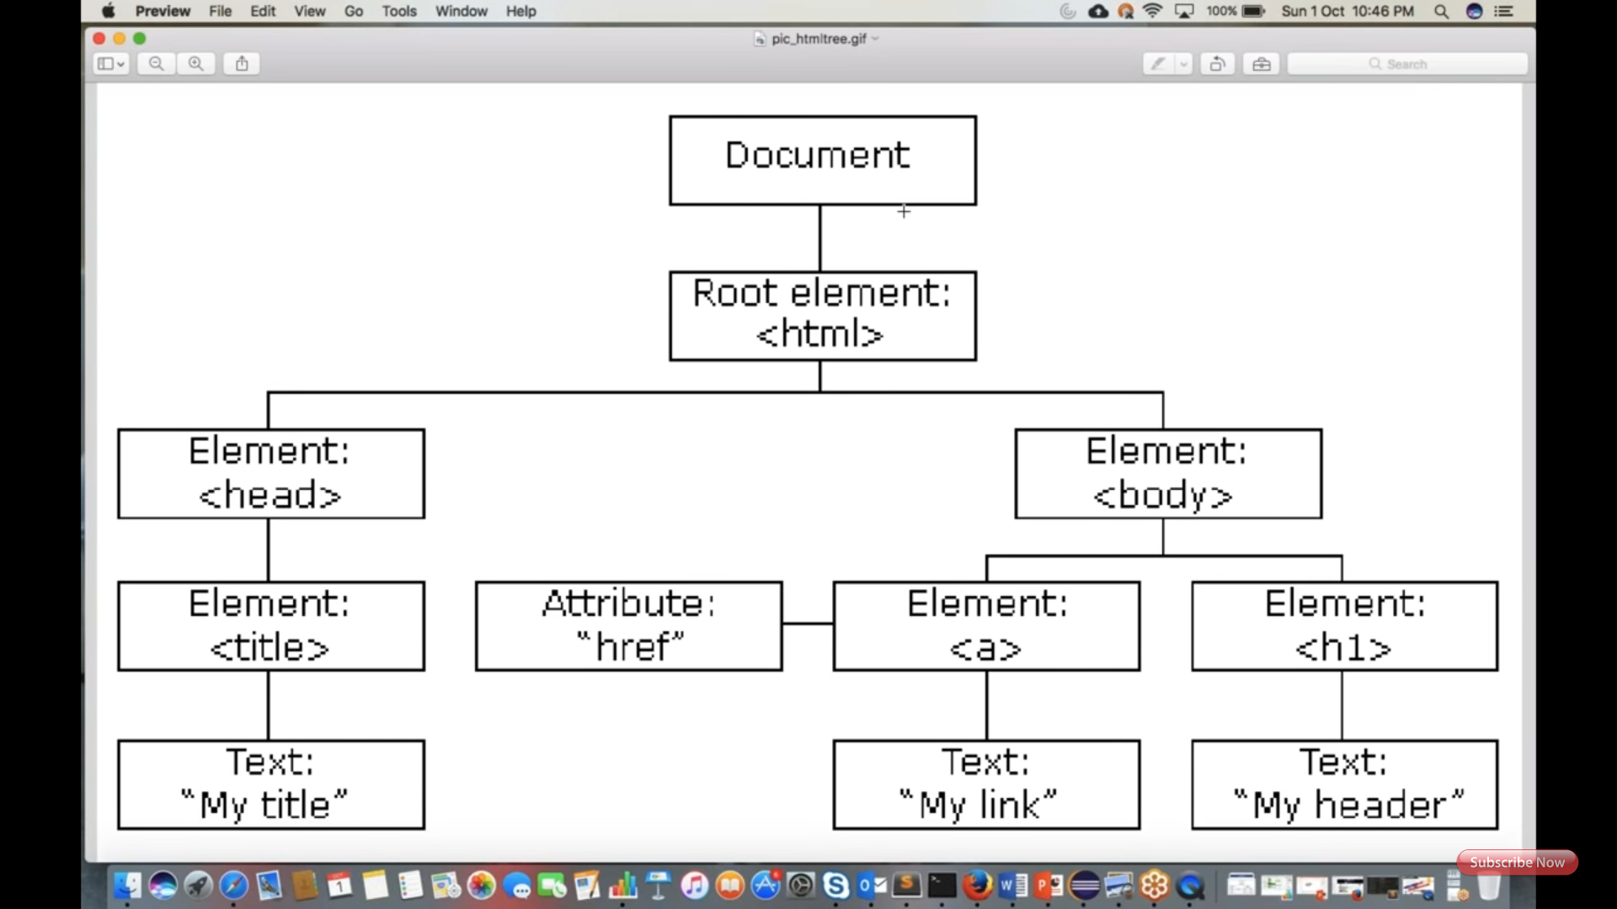

Third screenshot: Below code and Browser DOM explained with examples of JavaScript and Browsers in.

DOM is a platform or interface which is available in the form of APIs.

HTML DOM provided by browser vendor. Chrome, Firefox, IE, and so on.

CRUD APIs are accessed by the JavaScript and perform operation, each JavaScript is browser specific.

In any page, you take the List<WebElement> list = driver.findElements(By.xpath(---));

Refresh webpage

Try clicking on any of the above list eleminates.

You get StaleElementException. Reason: every page fresher or section got changed/updated, you get new DOM gets created.

To resolve the above issue, again we need to take the list and perform later operations.

Note: user not required to refresh, by clicking on the lin or tabs, page automatically refreshes.

Possible exceptions are:

StaleElementException

ElementNotFoundException

Element ReferenceException

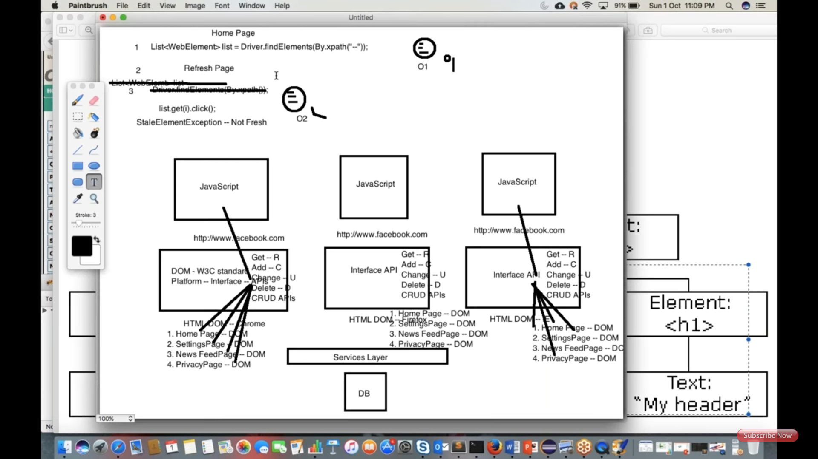

Forth screenshot has shown different DOM structures of browsers for the same application.

---------------------------------------------------

In HTML DOM, user can get properties, access methods, do some events.

Other DOM are..

XML DOM

CORE DOM.

In automation we use HTML DOM.

